Hotel Booking Cancellation Analysis Report

1. Executive Summary
This report presents an in-depth analysis of hotel booking cancellation data to identify key factors contributing to cancellations and provide actionable recommendations. The analysis reveals that approximately 37% of hotel reservations are canceled, with significant variations observed between resort and city hotels. Factors such as Average Daily Rate (ADR), booking lead time, and specific months of the year play crucial roles in cancellation patterns. The findings suggest strategic adjustments in pricing, promotional activities, and service quality can effectively mitigate cancellation rates and enhance revenue.

2. Introduction

2.1. Business Problem
Both City and Resort Hotels face substantial challenges due to high cancellation rates. This issue directly impacts revenue generation, operational planning, and resource allocation. Understanding the underlying causes of these cancellations is paramount for developing effective strategies to improve efficiency and profitability.

2.2. Research Questions
- What are the primary variables that influence hotel reservation cancellations?
- How can hotel reservation processes be optimized to reduce cancellations?
- How can hotels leverage data-driven insights to inform pricing and promotional decisions?

2.3. Hypotheses
- Higher Average Daily Rates (ADR) are positively correlated with increased cancellation rates.
- Longer lead times between booking and arrival tend to result in higher cancellation probabilities.
- A significant proportion of clients originating from specific market segments, such as online travel agents, may exhibit distinct cancellation behaviors.

3. Data Overview and Preparation
The dataset comprises detailed information on hotel bookings, including reservation status, lead time, arrival dates, guest demographics, and pricing. Initial data exploration involved examining data types, identifying missing values, and assessing the distribution of key variables. Missing values in the 'company' and 'agent' columns were addressed by dropping these columns due to their high sparsity. Remaining null values were removed, and an outlier in the 'adr' column (values greater than 5000) was filtered out to ensure data integrity for analysis.

4. Key Findings and Analysis

4.1. Overall Cancellation Rate
The analysis indicates that a substantial portion of bookings, specifically 37.13%, are canceled. This highlights the critical need for interventions to reduce these rates.

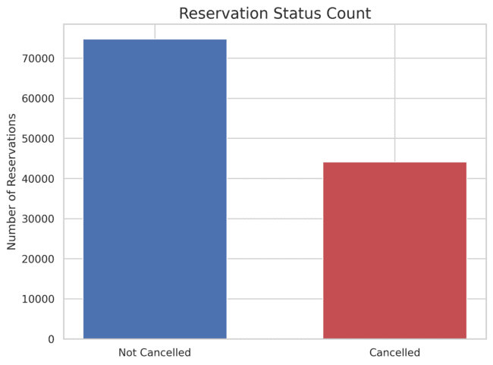

4.2. Reservation Status by Hotel Type
City Hotels experience a higher volume of bookings compared to Resort Hotels. While both hotel types face cancellations, the absolute number of canceled reservations is higher in City Hotels, suggesting a need for tailored strategies based on hotel type.

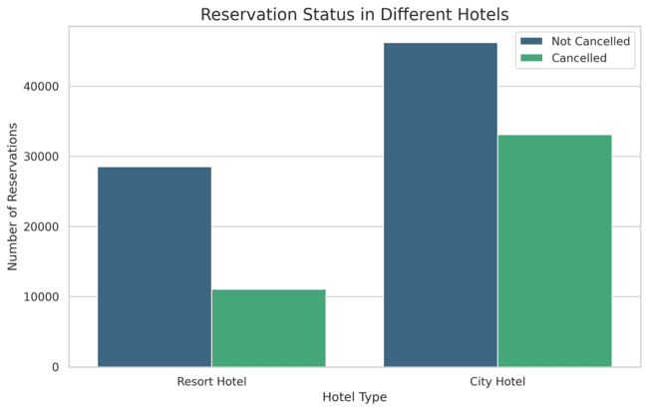

4.3. Average Daily Rate (ADR) Comparison
The Average Daily Rate (ADR) fluctuates significantly between City and Resort Hotels over time. Resort Hotels generally exhibit higher ADRs, particularly during peak seasons or weekends, which may influence cancellation decisions.

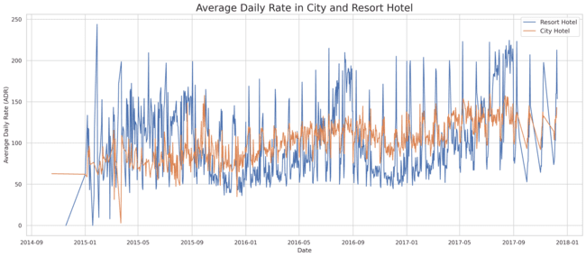

4.4. Monthly Reservation Trends and Cancellations
Reservation patterns and cancellation rates vary considerably throughout the year. August shows the highest number of reservations, both confirmed and canceled. Conversely, January records the highest proportion of canceled reservations, indicating a potential opportunity for targeted promotions during this month.

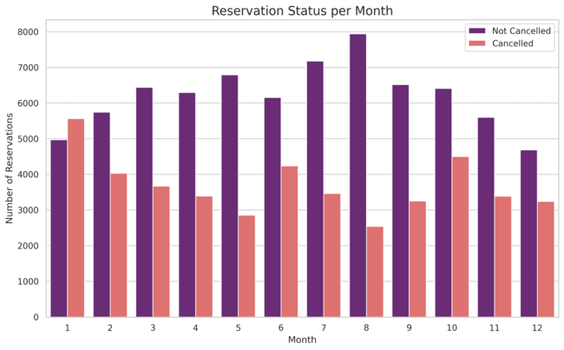

4.5. Monthly ADR for Canceled Bookings
An examination of ADR for canceled bookings by month reveals that higher ADRs often coincide with increased cancellation rates. This supports the hypothesis that pricing is a significant factor in guest decisions to cancel.

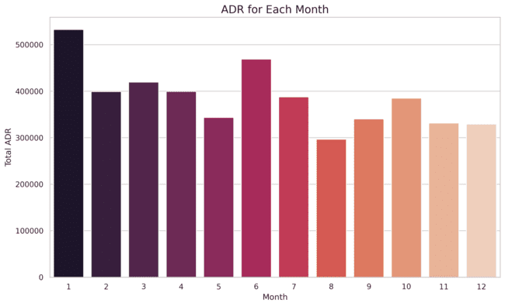

4.6. Geographic Analysis of Cancellations
Portugal (PRT) accounts for the largest share of canceled reservations among the top 10 countries, representing over 70% of all cancellations. This geographical concentration suggests that localized strategies could be highly effective.

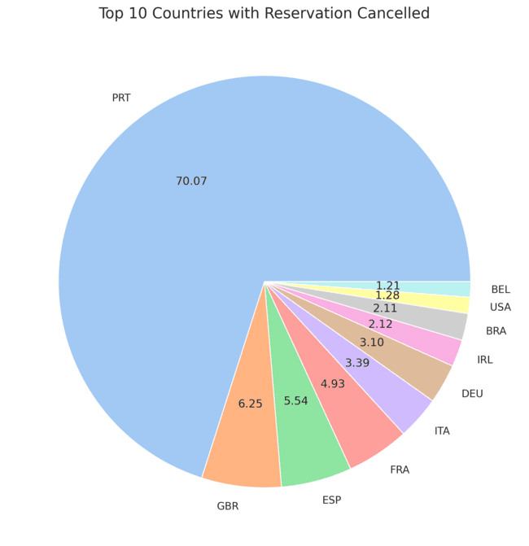

4.7. Market Segment Analysis
Market segment analysis shows that 46% of clients originate from online travel agencies, while 27% come from group bookings, and only 4% book directly. This distribution highlights the importance of managing relationships with various booking channels.

4.8. ADR for Canceled vs. Not Canceled Bookings
Comparing the ADR for canceled versus not-canceled bookings reveals that reservations with higher ADRs are more prone to cancellation. This reinforces the need for dynamic pricing strategies that consider cancellation risk.

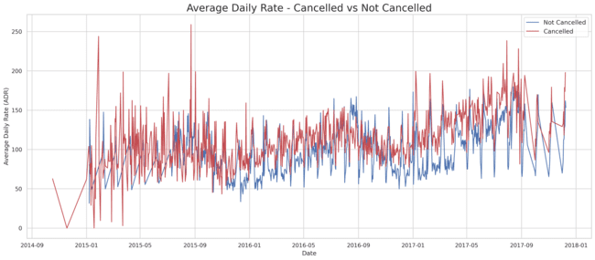

5. Recommendations
Based on the analysis, the following recommendations are proposed to mitigate hotel booking cancellations:

- Dynamic Pricing Strategies: Implement flexible pricing models that adjust based on demand, lead time, and historical cancellation data. Offer incentives for early bookings or non-refundable rates for specific periods.
- Targeted Promotions: Develop specific promotional campaigns for months with high cancellation rates, such as January, to stimulate demand and reduce cancellations. Consider offering discounts for longer stays or during off-peak periods.
- Enhanced Customer Engagement: Improve communication with guests post-booking, especially for reservations with longer lead times. Provide clear cancellation policies and offer options for rescheduling rather than outright cancellation.
- Geographic Focus: Given the high cancellation rate from Portugal, investigate specific market conditions or competitor strategies in this region. Tailor marketing efforts and service offerings to address the needs of guests from this country.
- Service Quality Improvement: Continuously strive to enhance the overall guest experience. Positive reviews and a strong reputation can reduce the likelihood of cancellations, particularly for higher-priced bookings.

6. Conclusion
By understanding the key drivers of hotel booking cancellations, hotels can implement data-driven strategies to optimize revenue and operational efficiency. The insights from this report provide a foundation for developing targeted interventions that address specific challenges and capitalize on opportunities to improve guest satisfaction and loyalty.

